Prepared by
Hemalee Leuva
Consultant: Minimum Standards of Care & MIS- ICPS, SJ & ED, Gujarat
Minutes of Meeting of NIC Delhi with Social Justice & Empowerment Department, Gujarat and UNICEF on developing MIS on Child Protection
Minutes of Meeting of NIC Delhi with Social Justice & Empowerment Department, Gujarat and UNICEF on developing MIS on Child Protection

Date: 4th May 2012
Venue: Info City, Indroda Circle, SG High way, Gandhinagar
Time: 11.00 am to 5.00 pm
Participants: Government officials from SJ & ED Department, Central Project Support Unit (CPSU) - Delhi, NIC team of Delhi and Gujarat, UNICEF, Superintendents , SDO, CWC chairperson, DCPOs, GSCPS, SPSU, SARA ( Annexure-2: List of Participants)
About the Meeting:
This meeting is organized by SJ & ED and UNICEF with NIC Delhi on developing Management Information System (MIS) on Child Protection in Gujarat.
Social Justice & Empowerment Department (SJ & ED), Gujarat has shared its concern for developing Child Tracking System in the state earlier to Ms. Neela Gangadharan, Secretary, WCD, GOI and also started further formal process for the same with GOI. It was also again requested to Ms. Preeti Madan, Joint Secretary, WCD, Delhi & Ms. Kalyani Chadda, Director, WCD, Delhi in the meeting organized by WCD on 16th April 2012 to include Gujarat as pilot state in priority basis as the state has established State and District level Structures. In this response, GOI was in principle agreed to include Gujarat as pilot state and requested Dr. Gautam Bose, DD, NIC to organize visit to Gujarat State and Gujarat NIC in first week of May 2012 to develop the Child Tracking System in the state.
As an outcome of this process, this meeting is organized in coordination with WCD, Delhi and NIC Delhi in Gujarat.
Minutes of the Meeting:
The meeting was started with the welcome note by Ms. Deena Patel, Deputy Director, Directorate of Social Defense (DSD). She welcomed the team from NIC & CPSU, functionaries from Home Department and all the invitees on behalf of Social Justice & Empowerment Department & UNICEF. She also thanked Government of India for selecting Gujarat as Pilot State in developing Child Tracking System (CTS) in Gujarat.
She shared current status of ICPS in Gujarat to the participants that ICPS is being implemented in Gujarat since 2009-10. DSD also registered Gujarat State Child Protection Society (GSCPS) and also SPSU & SARA team are on board and actively involved in the area of Child Protection. The structures at district level are also in place.
ICPS envisages developing an effective system for child protection data management and reporting. It is also planned in ICPS to develop a nationwide website for tracking missing children as well as creating live database by crating MIS for the children residing in various homes in the state.
She said that SJ & ED, Gujarat is quite sensitive and committed to initiate the Child tracking system in the state at the earliest. She requested all the invites as important stakeholders for developing the MIS to share their suggestions and feedbacks.
After the round of introduction of all participants, Mr. Lolichen P.J., Child Protection Officer, UNICEF addressed the participants. He shared about the child rights and need of development of MIS for child protection. He also shared about the district stakeholders workshops are being organized in each districts with the support of UNICEF. Looking at the Child Protection there could be many issues such as child labor, child marriage, child trafficking, etc. It is very necessary to develop an MIS with different indicators to monitor the progress on various child protection activities. NIC will help to materialize the informatics system to track the progress of the child enters in to JJ System.
Mr. Deepak Swaroop, Additional DGP, Home Department addressed the participants that Gujarat is one of the state who has developed E-Governance. He said that child should be in mainstream and so MIS on Child Protection related activities is very much required. The MIS should not be complicated and should be user friendly. He also shared his concerns to NIC Delhi for child tracking system that,
1) How day to day basis up gradation of data would take place?
2) The child tracking system would be working as an isolated system or it will be combined or linked with other states?

After the addressel by Deepak Swaroop, Ms. Hemalee Leuva, Consultant- Minimum Standards of Care and MIS- ICPS requested Dr. Gautam Bose to share about the child tracking system and expectations from the state.
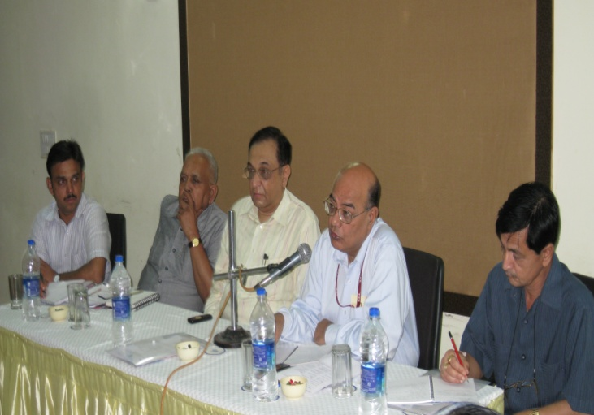
Dr. Gautam Bose gave introduction of “childtrack1.0”. The website would facilitate matching of missing and “found” children also. He said that it covers every aspect of child such as education, heath. Some of the states are trying to develop the systems in Karanataka, Orrissa, Delhi, etc. initially will be piloted in 4 to 5 states where in Gujarat is one of them. This will be done by June 12 & eventually in all the states. State level, block level officials will be stakeholders who will get the report and access information.
Initially it was started in WB with missing persons and then further it linked with missing children. West Bengal pilot phase experience of developing child tracking system which has two components such as website for missing children as well as live data base of children residing in various child care institutions and to monitor the progress of each child. This will not work as an isolated system but would be linked with other states eventually.
He also said that all stakeholders are expected to update the system as and when data/information is collected. Awareness generation regarding such website is also required. He explained that this system is very user friendly and will be able to generate month wise reports.
He shared that this meeting is expected to be fruitful in terms of rolling out the child tracking system in state. He shared his expectations of the meeting such as,
- To get the feedback and recommendations if any for freezing out the CTS to be developed by NIC in Gujarat
- To get the status of the CCIs of state, number of children, computer and internet availability and accessibility, existing missing children tracking system of the states
- Finalize the requirements for the proposed system
- Action Plan development to roll out the child tracking system in the state
After this, Mr. Subroto Roygupta, Scientist, NIC, West Bengal was requested to demonstrate the child tracking system developed by NIC, Delhi.
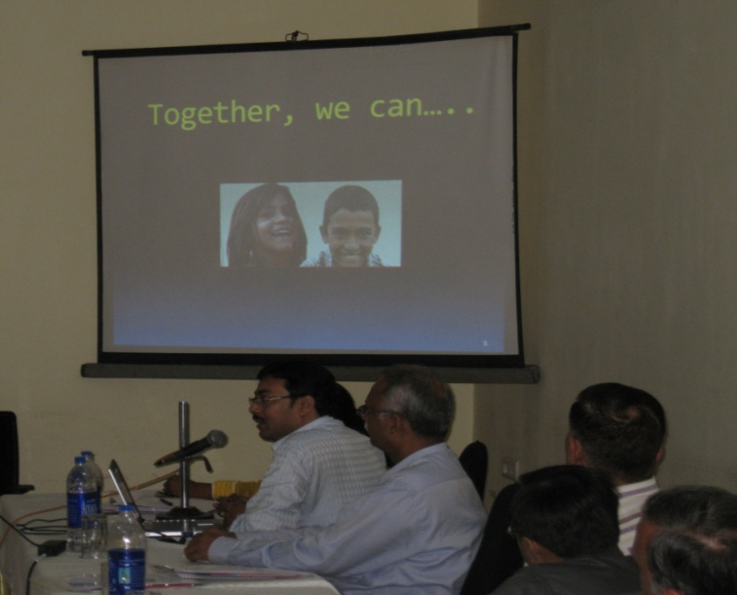
Mr. Subroto, NIC, WB shared the presentation demonstrating west Bengal experience on CTS as well as Track child1.0 – National Tracking System for Missing & JJ Home children. He explained that this system would ensure proper care and development of the children of the JJ home and also will ensure ultimate repatriation and rehabilitation of the missing children. The website will not only have data on missing children but it will also have live database to monitor the progress of the children in the institutions. NIC is developing the prototype to design the software to be used for entering the data on missing and found children

He also shared major challenges & steps taken in tracking missing children such as ensuring 100% reporting of cases, capturing details of cases into a central data repository and matching missing & found children.
He explained portal facilities, features of the system, linkages of the system with Education Portal & PRI Homepage of P & RD Portal, administrative measures, implementation status in WB, increasing reporting trends in WB, success stories and national roll out plan.
He also explained that the Web Portal will be accessed by the officers of MWCD at the Centre, Officers of the State Governments and SCPS, DCPU, Police, Institutional Staff of CCI registered under ICPS, Members of CWC, JJB, selected NGOs and certain information will be assessed by the general public also. The web portal/software will be easily accessed anywhere, anytime, 24*7 by all authorized stakeholders through secured and role based access.
The West Bengal models set up by NIC had widest coverage with interfaces like police, children’s homes, statutory structures, NCRB and citizens. On the basis of the report the Ministry of Women and Child Development (MWCD) had requested National Informatics Center (NIC) to develop a National Portal on the West Bengal Model for tracing missing children and to create a data base on the progress of children covered in the Institutions under JJ Act/ICSP system.

The Home Department also shared the standard operating procedures developed by Home Department for tracking of missing children in the state.
After the presentation of Mr. Subroto, Ms. Hemalee requested all participants to give their questions, recommendations/suggestions to freeze the Track child 1.0 and its links with JJB, CWC, Police, CCI, general public, etc.
Following questions were raised by participants after the live demonstration of the child track 1.0
Questions raised by participants | Resolved by NIC, Delhi
Will training provided to police? | This will be done when departmental order will be passed
There are various divisions such as A, B, C in police stations, this will be part of the MCTS | No
What would be cost sharing for training for CTS | Training for master trainers will be provided by NIC, Delhi & GOI and further trainings of the stakeholders will be the responsibility of the State Government
If the child is missing and his parents are found within 24 hours, then also data will have to be entered of that child? | Wherever the child is reported, data has to be entered mandatory
If child is deaf and dumb and he/she is not able to give details. In this case how this portal can be helpful? | This issue shall be addressed personally by taking help of expert of sign language, collect the data as much as possible
In case of transfer of child, what would be the system for providing ID to the child? | The same ID will be also transferred to the place where child is being transferred

Following suggestions were given by participants:
- Local language interface with the system
- SJPU interface with the system
- Important information on child should be available in vernacular language in the system
- Reasons for missing child/run away child should be included in the portal
- Reports to be generated at various level
- NCRB database should be linked
- Toll free helpline should be dedicated to the portal
- Data entry option for transgender child should be included
- Training should be organized frequently
- Name of the portal may be changed as “child track” seems creating stigma against child
- Child/children word must be replaced wherever “Inmate” word is used
Following activities to be done by State Government for roll out of MIS on Child Protection in the State
- Preparing Action Plan by project committee members to roll out the MIS in pilot phase in the state
- Follow up with Home Department for taking list of police stations with computer and internet connection
This meeting was concluded with vote of thanks by Mr. Devendra Bhatt, DS, SJ & ED. After this meeting, members of project committee met to discuss the action plan.
MEETING WITH PROJECT COMMITTEE MEMBERS FOR DEVELOPING ACTION PLAN TO ROLL OUT CHILD TRACKING SYSTEM IN PILOT PHASE IN GUJARAT
All the members of the project committee which is formed to develop and monitor the CTS had a meeting to discuss the Action Plan to roll out the CTS in the state with the coordination of NIC Delhi & NIC Gujarat. Following members were present during the meeting.
Sr. No. | Name of Participants
1 | Mr. R.S. Patel, IAS, Director, Social Defence as Chairman & Convener of project committee
2 | Mr. Anil Pratham, IGP, Crime Branch, Home Department as project committee member
3 | Mr. Anil Patni, PI, Missing Cell, Crime branch, Home Department, as project committee member
4 | Mr. Lolichen P.J., Child Protection Officer, UNICEF, as project committee member
5 | Mr. Mehul Patel, MASTEK ( Total Solution Provider to SJ & ED, Gujarat) , as project committee member
6 | Mr. Rajnish Mahajan, sr. Technical Director, Gujarat NIC, as project committee member
7 | Mr. Anand Shah, Principal systems Analyst, Gujarat NIC, as project committee member
8 | Representative from GIL, as project committee member was absent
9 | Dr. Gautam Bose, Deputy Director General, NIC, Delhi
10 | Dr. S.S. Singh, Technical Director, Delhi
11 | Mr. Subroto Roygupta, Scientist, NIC, West Bengal
12 | Ms. Shama Khan, Programme Officer, Central Project Support Unit (CPSU), WCD, Delhi
13 | Mr. Devendra Bhatt, Deputy Secretary, SJ & ED
14 | Ms. Deena Patel, Deputy Director, DSD
15 | Ms. Neeta Shukla, Assistant Director, DSD
16 | Ms. Hemalee Leuva, Consultant- Minimum Standards of Care & MIS- ICPS, SJ & ED
17 | Mr. Dhruv Joshi, Technical Consultant- ICPS, SJ &ED
18 | Ms. Hiral Pandya, Project Officer, SPSU
19 | Mr. Vijay Christian, Programme Manager, IEC & Training, GSCPS
20 | Mr. Tapan Updadhyay, Programme Officer, SARA

ACTION PLAN
SJ & ED, Gujarat agreed to develop the Child Tracking System in Gujarat under ICPS through NIC Delhi in coordination with NIC Gujarat. This Child Tracking System would have two components:
- Website for missing children
- Live database for monitoring the progress of children comes under JJ System and residing in Child Care Institutions
It was decided to initiate pilot phase in Gujarat State and following Action Plan is developed after discussion with NIC, Delhi and CPSU for the state to roll out the Child Tracking System in the state.
SR. NO | ACTIVITIES | TIME LINE | RESPONSIBLE AGENCY
1 | User acceptance- testing of functionalities features of the software | 15th -16th May 2012 | NIC Delhi
2 | Selection of Child Care Institutions (CCI), Child Welfare Committees (CWCs), Juvenile Justice Boards (JJBs) for pilot phase | 12th May 2012 | DSD, SPSU
3 | Issuing orders for selected CCIs for pilot | 15th May 2012 | DSD, SPSU
4 | Selection of master trainers- comprising officials from State Government, GSCPS, SPSU, SARA, CCIs, JJBs, CWCs, Police, State NIC | 15th May 2012 | DSD, SPSU
5 | Orientation of master trainers on case history and Individual Care Plan | 18th May 2012 | SPSU
6 | Ensuring computer and internet connectivity in selected CCIs for pilot | 20th May 2012 | DSD, SPSU
7 | Identification of training venue with availability of computer and internet connectivity | 20th May 2012 | GSCPS, SPSU
8 | Selection of Special Juvenile Police Units (SJPUs) for pilot | 20th May 2012 | Home Department
9 | Preparation & Digitalization of case history and individual care plan in selected CCIs | 25th May | SPSU
10 | Training of master trainers on child tracking system childtrack1.0- providing User ID & Password to stakeholders | 3rd or 4th Week of May 2012( yet to be decided by WCD, Delhi) | NIC Delhi
11 | Data entry by CCIs, CWCs, JJBs, Police- data is regularly uploaded and updated with NIC assistance at a regular frequency into the system | 20th June 2012 | Selected CCIs
12 | Launching of the system | 22nd June 2012 | State Government, NIC Delhi

ANNEXURE 1: AGENDA OF THE MEETING

Meeting of NIC Delhi with Social Justice & Empowerment Department and UNICEF on developing MIS on Child Protection
PROGRAMME SCHEDULE
Date: 4th May 2012
Time: 11.00 am to 3.00 pm
Venue: Info city Clubs & Resort, SG Highway, Gandhinagar
Time | Activity | Facilitator
11.00 am to 11.10 am | Registration | Mr. Tapan Upadhyay & Mr. Bharat Nakum, State Team
11.10 am to 11.20 am | Welcome and participant introduction | Ms. Deena Patel, Deputy Director, Directorate of Social Defense
11.20 am to 11.30 am | Brief introduction to Child Protection & objective of the workshop | Mr. Lolichen P.J. Child Protection Officer, UNICEF
11.30 am to 11.40 am | Views & Expectation on Child Tracking System from NIC, Delhi | Mr. Sanjay Prasad, IAS, Principal Secretary, Social Justice & Empowerment Department ( SJ & ED)
11.40 am to 11.55 am | Views on missing children scenario in Gujarat & status | Home Department
11.55 am to 1.00 pm | Technical Presentation | National Informatics Center, Delhi
1.00 pm to 2.00 pm | Discussion with Participants | Hemalee Leuva, Consultant- MIS, ICPS, SJ & ED & Vijay Christian, Programme Manager, GSCPS
2.00 pm to 2.10 pm | Conclusion & Way Forward | Mr. Devendra Bhatt, Deputy Secretary, SJ & ED
2.00 pm onwards | Lunch

ANNEXURE 2: LIST OF PARTICIPANTS
MCTS Meeting on 4th May, 2012
St. No | Name and Designation | Departemt | Contact No | email-id
1 | Sandip Parmar  SDD | Children Home  Matruchhaya Nadiad | 9898011622 | matru_28dec@yahoo.co.in
2 | Neetaben Shukla  Asst. Director | Social Def.Dept.  Gandhinagar | 079-23256320 | neetashukla196@yahoo.com
3 | Mayank Trivedi  Superintendent | Children Home  Ahmedabad | 9824944100 | mayanktrivedi444@gmail.co.in
4 | Nirav Dave  Superintendent | Children Home  Rajkot | 9426854571 | niravjdave@yahoo.co.in
5 | A.F.Patel  SDO | Himatnagar Dist | 9879075650 | maheshpatelsoch@rediffmail.com
6 | Vijay Christian  Programme Managaer | GSCPS,  Gandhinagar | 9033573798 | gujarat.icps@gmail.com
7 | Tapan Upadhyay  Programme Officer | SARA, GSCPS,  Gandhinagar | 9974093599 | gujarat.icps@gmail.com
8 | Prakash Trivedi  SDO | Amreli Dist | 9428711990 | sdo-amr@gujarat.gov.in
9 | Sahadev K Ishrani  SDO | Jamnagar Dist | 9824294670 | sdo-jam@gujarat.gov.in
10 | Dr.Jagdish patel  Chariman | CWC- Surat | 9662500625 | drjagdishpatel@yahoo.com
11 | Komal Sharma  Trainee Officer | GSCPS,  Gandhinagar | 9227362236 | gujarat.icps@gmail.com
12 | Hiral D Pandya  Project Officer | SPSU, GSCPS,  Gandhinagar | 9904978735 | gujarat.icps@gmail.com
13 | Lolichen P.J  UNICEF | UNICEF | 9909011264
14 | R.S.Patel  IAS | Director of Social Defence Dept | 9978405578 | dir_sd@gujarat.gov.in
15 | Anil Pratham  IGP | CID, Crime Branch  Gandhinagar | 9978405257 | apratham@gmail.com
16 | Devendra H Bhatt  Dy.Secratory | Social Justice Dpt. | 9824169972 | -
17 | Milan Motavar  Project Manager | GIL, Gandhinagar | 9726351115 | milanm@gujarat.gov.in
18 | Anil S Patni  Missing Cell | CID, Crime Branch  Gandhinagar | 8980047154 | cor.crime@gujarat.gov.in
19 | M.N.Modi  Under Secratory | Home Dept. | 079-23250529 | uscompl.home
20 | Mr. Qureshi  Under Secratory | SJ&ED, Gandhinagar | 9924317084 | -
21 | Rajnish Mahajan  Sr. Tech. Trivedi | NIC, Gandhinagar | 9426477266 | sio-guj@nic.in
22 | Anand Shah  Principal Systorms Analisist | NIC, Gandhinagar | 9427600830 | anand.shah@nic.in
23 | Dr. S.S.Singh  Technical Director | NIC, Gandhinagar | 9873549889 | sssingh@nic.in
24 | Rot Rameshchandra Kalaji  DCPO- Ahmedabad | DCPU- Ahmedabad | 9825590465 | rameshrot@yahoo.com
25 | Amit Vasava  DCPO-Vadodara | DCPU- Vadodara | 9879487248 | amitvasavamsw@gmail.com
26 | Bharat Nakum  Project Officer | SPSU- Gandhinagar | 9924025050 | gujarat.icps@gmail.com
27 | Smt. Deenaben Patel  Dp.Director | Social Defence Dept. | 9427012433 | dis_sd@gujarat.gov.in
28 | Mehul Patel  Engaqement Manager | Mastek.Ltd | 9662545351 | mehul.patel@mastek.com
29 | Jamaluddin A. Saiyad  Section Officer | SJ&ED | 9898162266 | so-sje@gujarat.gov.in
30 | Dhruv Joshi  Technical Consultant-ICPS | SJ&ED | 9909944394 | dhruvkumar.joshi@gmail.com
31 | Hemalee Leuva  Consultant-MIS | SJ&ED | 9825446666 | hemaleeleuva@gmail.com
32 | Dr. Gautam DD | NIC, Delhi | 09811119633 | -
33 | Mr. Subaoto  Scientist | NIC, Delhi | 09434251445 | -

